MINI PROJECT REPORT ON

GESTURE CONTROL MOUSE

SUBMITTED TO THE SAVITRIBAI PHULE PUNE UNIVERSITY, IN THE PARTIAL FULLFILLMENT OF THE REQUIREMENTS FOR THE AWARD OF THE DEGREE (BE)
OF

THIRD YEAR OF ENGINEERING
(ELECTRONICS & TELECOMMUNICATION)

PRATIK RAJ HARSH Exam no:3224
ARNAV SHIKETODE Exam no:3236
SUMIT BHAVSAR Exam no:3243

Under the Guidance of Mrs. Supriya A. Dhoke


DEPARTMENT OF ELECTRONICS & TELECOMMUNICATION ENGINEERING
(Accredited By NAAC ‘A+’ Grade) PUNE - 411 048
2025-2026

CERTIFICATE

I hereby certify that the work which is being presented in the Mini Project report entitled GESTURE CONTROL MOUSE in partial fulfillment
of the requirements for the award of the Third of the Engineering in Electronics & Telecommunication Engineering and submitted to the Electronics & Communication Engineering department of KJEI’s Trinity Academy of Engineering College, Pune is an authentic record of my own work carried out during a period from January 2026 to May 2026 under the supervision of Mrs. Supriya A. Dhoke, E&TC Department.
The matter presented in this project report has not been submitted by me for the award of any other degree elsewhere. This is to certify that the above statements are correct to the best of my knowledge.

Mrs. Supriya A. Dhoke

PROJECT GUIDE

Dr. D.D. Kulkarni Dr. R.J. Patil
HOD (E&TC) PRINCIPAL, TAE

EXTERNAL EXAMINER

ACKNOWLEDGEMENT

To put an effort like this requires the determination and help of many people around us and we would not be doing justice to their efforts by not mentioning each helping hand in person.
We are highly thankful to Mrs. Supriya A. Dhoke for their guidance and constant supervision as well as for providing necessary information regarding the project
We express our sincere gratitude to Mrs. Supriya A. Dhoke Mini Project Coordinator (E&TC Dept),
Dr. D.D.Kulkarni (Head of E&TC Engineering Department), Dr. Rupesh J. Patil, Principal of Institute and other Teaching and Non-teaching staff members of the Electronics & Telecommunication Engineering Department for their kind cooperation.
We would like to give sincere thanks to the Library Department for their kind cooperation throughout our work. And people who have willingly helped us out with their abilities.
We would like to express gratitude towards our parents for their kind cooperation and encouragement which help us in working on this project.

Date:
Place: TAE, Pune.

ABSTRACT

With the rapid advancement of human–computer interaction technologies, touchless control systems are gaining significant importance. Gesture recognition provides a natural and intuitive way for users to interact with digital devices without physical contact. In this context, gesture-based input devices offer an innovative alternative to traditional mouse and keyboard interfaces. This project presents the design and implementation of a economical Gesture-Controlled Mouse using the MPU6050 motion sensor, flex sensor, and NodeMCU (ESP8266) microcontroller. The system enables touchless human-computer interaction by translating natural hand gestures into real-time cursor movements and click actions.

The MPU6050 sensor, which combines a 3-axis accelerometer and 3-axis gyroscope, detects hand tilt and orientation along the X and Y axes. These motion values are processed by the NodeMCU and transmitted to a computer via serial communication. A flex sensor mounted on the index finger detects bending motion, which is mapped to mouse click functionality. A lightweight Python script using libraries such as pyserial and pyautogui converts the received data into native mouse commands.

Unlike camera-based gesture systems, this design eliminates the need for image processing, reducing computational complexity, latency, and privacy concerns. The system is portable, energy-efficient, and cost effective, with a total build cost under 1200 rupees.

This project demonstrates an affordable and practical approach to touchless computer control and has potential applications in accessibility systems, gaming interfaces, robotics control, and smart human-machine interaction. Future enhancements may include wireless communication via Bluetooth, additional gesture recognition, and machine learning-based customization.

LIST OF TABLES

Table No | Title | Page No.
2.1 | Bill of Materials | 3

LIST OF FIGURES

Figure No | Title | Page No.
3.1 | Circuit Diagram | 4
3.4.1 | Block Diagram | 7
3.4.2 | Flow Chart | 8
4.1.1 | Hardware Setup | 9
4.1.2 | Hardware Setup | 9

TABLE OF CONTENTS

CONTENTS |  | Page  No.
Acknowledgement |  | i.
Abstract |  | ii.
List of Tables |  | iii.
List of Figures |  | iv.
CHAPTERS
1. | INTRODUCTION | 1
2. | LITERATURE SURVEY | 2
3. | PRESENT WORK | 4
 | 3.1 Circuit Diagram | 4
 | 3.2 Hardware Used | 5
 | 3.3 Implementation Procedure/Methodology | 6
4. | RESULT AND DISCUSSION | 9
 | 4.1 Hardware Results | 9
5. | CONCLUSION AND FUTURE SCOPE | 10
6. | REFERENCES | 11

INTRODUCTION

The idea for the Gesture-Controlled Mouse originated from a practical problem observed in educational environments. Teachers and presenters frequently face interruptions during lectures when they need to move back and forth between the board and the computer to control slides or navigate content. This constant movement disrupts the natural flow of teaching, reduces engagement, and makes presentations less effective. To address this real-world challenge, a wearable, gesture-based system was designed that allows the user to control the computer remotely using simple and intuitive hand movements, without the need to physically touch the system.

In recent years, human-computer interaction (HCI) has evolved significantly, with increasing focus on touchless and contactless control systems. Technologies such as gesture recognition, Internet of Things (IoT) devices, voice assistants, and AI-based interfaces have gained widespread attention. However, most of the existing gesture-based solutions available today rely heavily on camera systems and computer vision techniques, which require high computational power, complex processing pipelines, and significant hardware resources. These systems are not only expensive but are also highly sensitive to environmental conditions such as lighting, background noise, and camera angle, making them unreliable in real-world settings like classrooms or offices.

This project addresses these limitations by contributing a simple, efficient, and low-cost alternative. Instead of relying on cameras or vision-based systems, the solution uses an MPU6050 gyroscope and accelerometer sensor combined with a flex sensor, interfaced with the NodeMCU (ESP8266) microcontroller. The MPU6050 captures hand orientation and tilt to control cursor movement, while the flex sensor detects finger bending to perform mouse click actions. This sensor-based approach completely eliminates the need for cameras, significantly reducing both hardware cost and computational complexity.

Overall, this project delivers a portable, wearable, and user-friendly solution that is well-suited for a wide range of applications including education, accessibility for differently-abled individuals, smart home interaction, and industrial control environments where touchless input is preferred or necessary.

LITERATURE SURVEY

Extensive research has been conducted in the field of gesture recognition systems for human-computer interaction, with various approaches being explored to develop more natural and efficient input methods. A comprehensive survey by S. Rautaray and A. Agrawal examined vision-based hand gesture recognition techniques, covering a wide range of methods including image processing, background subtraction, and pattern recognition algorithms. While their work provided a strong foundation for understanding gesture-based systems, it also highlighted a critical limitation — such vision-based approaches are highly dependent on ambient lighting conditions, camera resolution, and background complexity. Any variation in these environmental factors can significantly degrade the accuracy and reliability of the system, making them unsuitable for real-world deployment in uncontrolled environments such as classrooms or offices.

P. K. Bora and S. K. Sarma proposed a virtual mouse system based on computer vision, which offered the advantage of eliminating the need for additional hardware peripherals. By using only a webcam and image processing algorithms, their system allowed users to control the cursor through hand movements captured visually. However, despite its hardware independence, this approach introduced challenges related to processing latency, computational load, and reduced accuracy under varying lighting and background conditions. The system's dependence on continuous video feed also raised concerns regarding real-time responsiveness and privacy.

A significant comparative study by Chaudhary et al. evaluated and contrasted three major categories of gesture recognition systems — glove-based, vision-based, and sensor-based approaches. After thorough analysis, the study concluded that sensor-based systems offer superior reliability, consistency, and accuracy compared to the other two categories. Sensor-based systems are not affected by environmental lighting, do not require high computational resources, and provide direct, precise measurements of hand movements, making them a more practical and dependable choice for real-time applications.

Taken together, these research findings strongly support the approach adopted in this project — combining the MPU6050 sensor for motion tracking with a flex sensor for finger detection, interfaced with the NodeMCU microcontroller, to build a reliable, low-cost, and camera-free gesture-controlled mouse system.

Bill of Materials

Sr. No. | Component Description | Quantity | Approx. Unit Price (₹) | Total Cost (₹)
1 | NodeMCU (ESP8266) Microcontroller | 1 | 450 | 450
2 | Flex Sensor | 2 | 150 | 300
3 | 10kΩ Resistor | 2 | 10 | 20
4 | Glove | 1 | 50 | 50
5 | Jumper Wires | 3 set | 20 | 60
6 | USB Micro Cable | 1 | 80 | 80
7 | PCB Board | 1 | 40 | 40
8 | Breadboard (Mini) | 1 | 60 | 60
 | GRAND TOTAL |  |  | ₹ 1060.00

PRESENT WORK

Circuit Diagram
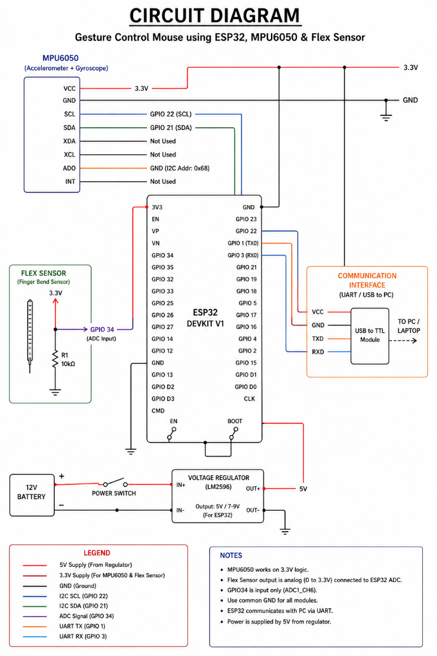

Figure 3.1

Hardware Used

- MPU6050 (Accelerometer + Gyroscope Sensor):
The MPU6050 is a motion tracking sensor that combines a 3-axis accelerometer and a 3-axis gyroscope. It is used to detect hand movements and orientation in real time. In the gesture-controlled mouse system, this sensor captures tilt, rotation, and motion of the hand, which are then translated into cursor movements on the screen.

ESP32Microcontroller:
The ESP32 is a powerful microcontroller with built-in Wi-Fi and Bluetooth capabilities. It acts as the main processing unit of the system, receiving data from sensors (MPU6050 and flex sensor), processing it, and transmitting the corresponding commands to the computer. Its high processing speed and wireless communication make it ideal for real-time applications.

- FlexSensor:
A flex sensor is used to detect bending or flexing motion. Its resistance changes when it is bent. In this project, the flex sensor is typically attached to a finger to detect gestures like clicking actions (e.g., bending the finger for a left click). It enhances gesture recognition accuracy.

- PCB (Printed Circuit Board) :
The PCB is used to mount and connect all electronic components in a compact and organized manner. It replaces messy wiring and improves reliability, durability, and ease of handling of the circuit.

ConnectingWires:
Wires are used to establish electrical connections between different components such as sensors, microcontroller, power supply, and other modules. They ensure proper signal and power transmission throughout the system.

- 10kΩ Resistor:
A 10kΩ resistor is used as a pull-down resistor in the voltage divider circuit along with the flex sensor. When the flex sensor bends, its resistance changes, and the resistor helps convert this change into a measurable voltage at the analog pin (A0) of the NodeMCU. Without this resistor, the analog readings would be unstable or floating. It ensures accurate and consistent flex detection throughout the gesture recognition process.

Implementation Procedure / Methodology

- System Design and Planning:
The system architecture is planned by identifying required components (ESP32, MPU6050, flex sensor, power supply). Hand gestures captured by sensors are translated into mouse actions through software processing.

- Hardware Setup:
Components are assembled and connected — MPU6050 via I2C (SDA/SCL), flex sensor via voltage divider on an analog pin, a buck converter for voltage regulation, and an on/off switch for power control. All connections are secured on a PCB.

- Sensor Data Acquisition:
The MPU6050 reads acceleration and angular velocity, while the flex sensor detects finger bending. Both are continuously read by the ESP32 in real time.

Microcontroller Programming:
The ESP32 is programmed using Arduino IDE to process sensor data, filter noise, and extract tilt angles and gesture states, which are then transmitted to the computer via serial or Bluetooth.

- Gesture Recognition:
A Python program (VS Code) interprets incoming data — hand tilt → cursor movement, finger bend → mouse click, combined gestures → scrolling. Sensor values are mapped to screen coordinates and mouse events.

- Mouse Control Execution:
Using PyAutoGUI, recognized gestures are converted into cursor movement, left/right clicks, and scrolling — replacing the physical mouse entirely.

- Testing and Calibration:
The system is tested under varied conditions. Sensor values are calibrated and software/hardware adjustments are made to reduce noise, delay, and false triggers.

- Final Integration:
All modules are combined into a compact, portable system optimized for smooth real-time gesture-based mouse control.

Block Diagram

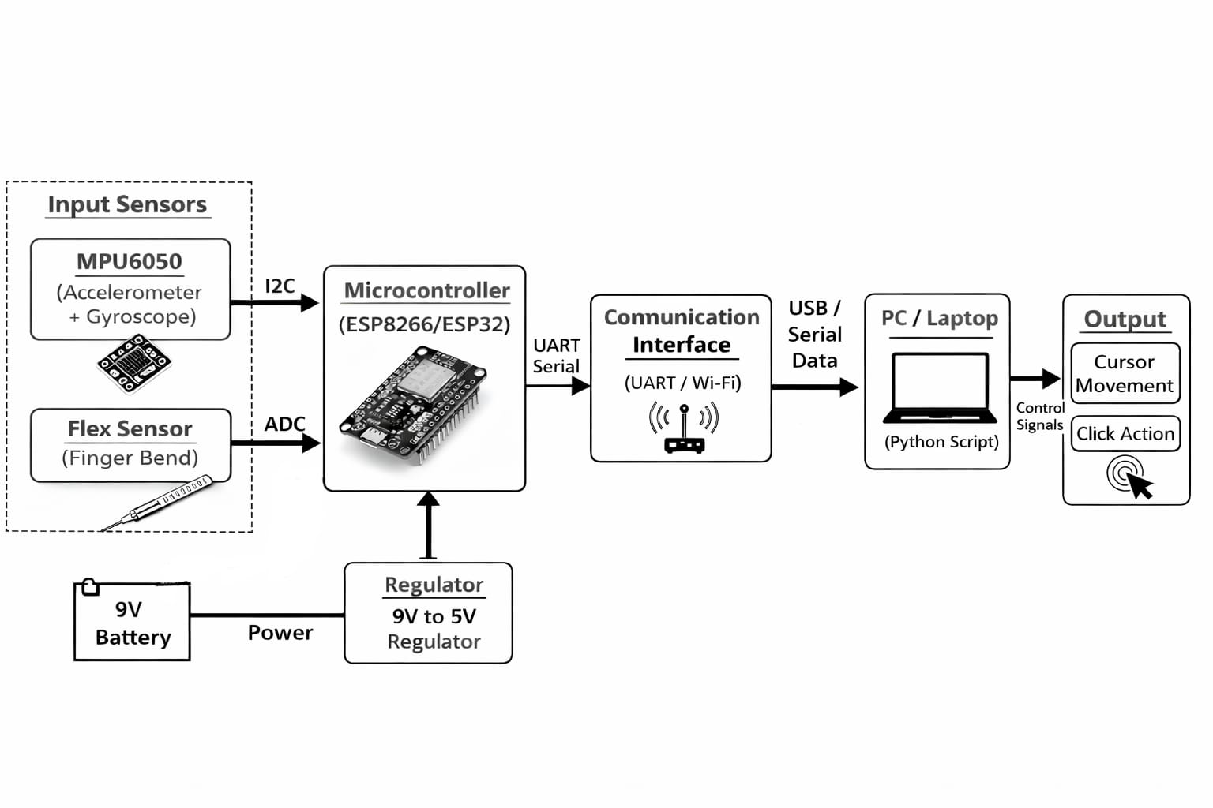

Figure 3.4.1

Flowchart

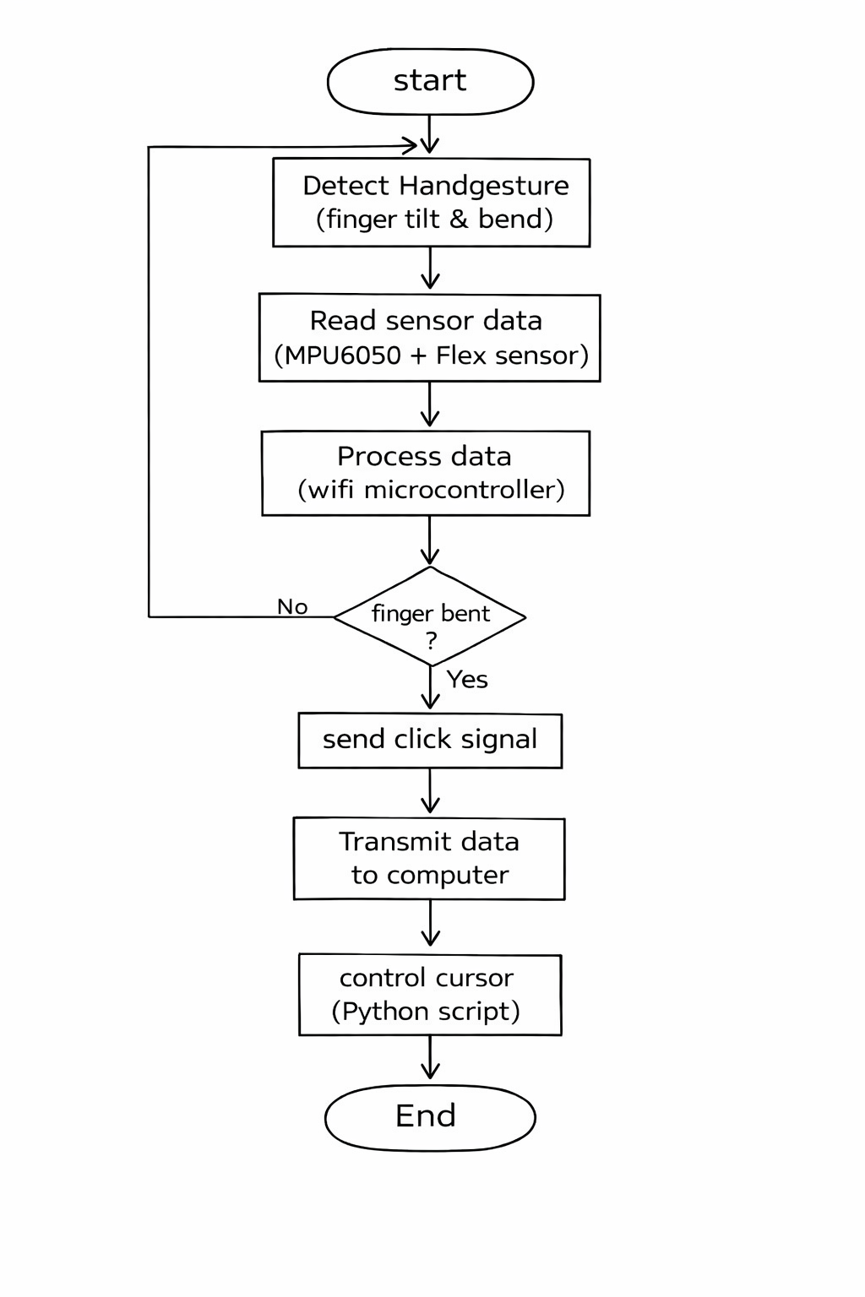

Figure 3.4.2

RESULT AND DISCUSSION

Hardware Results
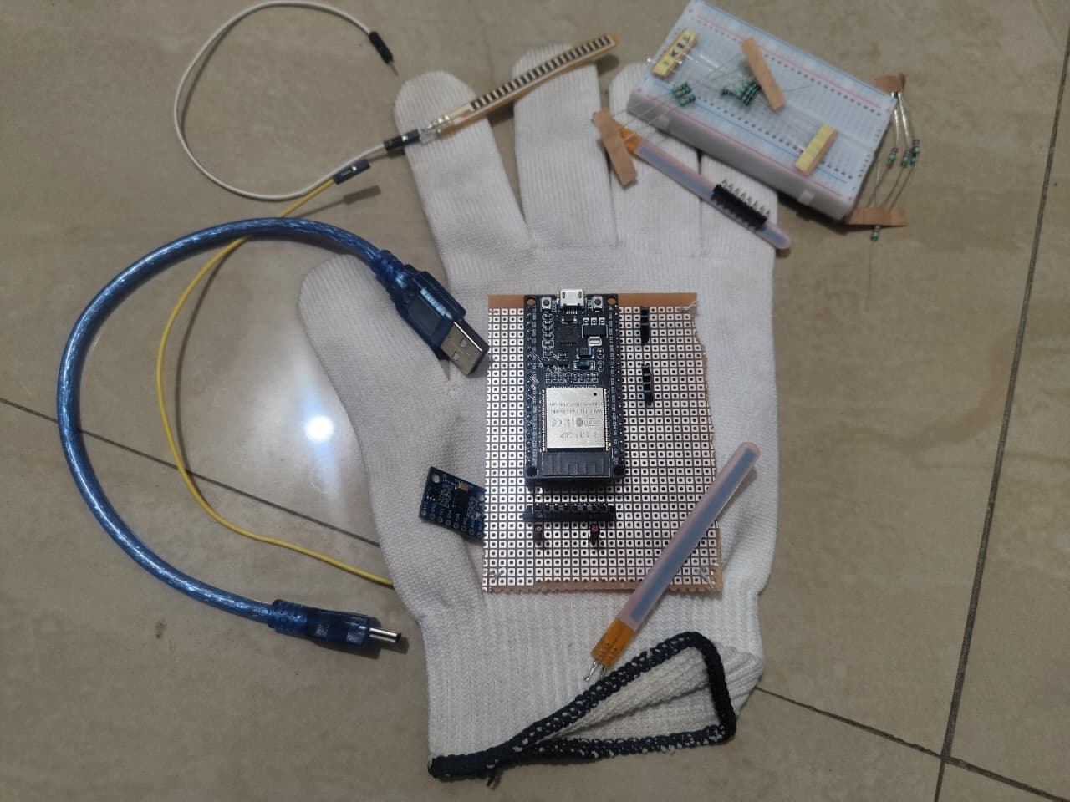

Figure 4.1.1 (Hardware Setup)

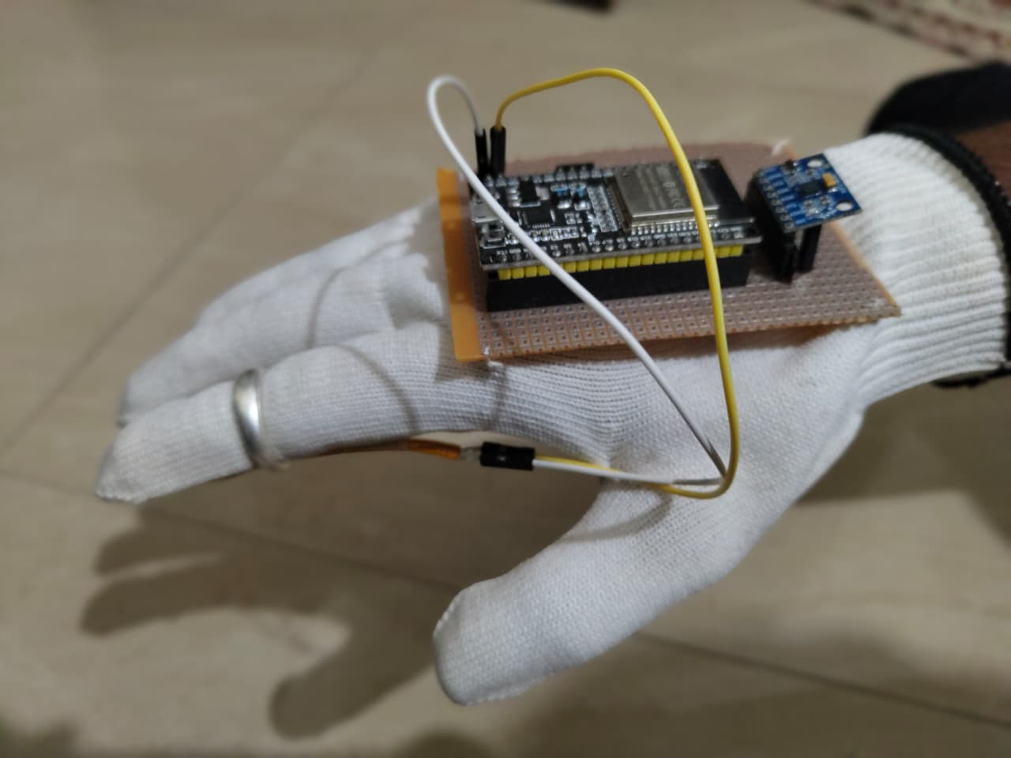

Figure 4.1.2 (Hardware Setup)

5 CONCLUSION AND FUTURE SCOPE

Conclusion
The Gesture Controlled Mouse system was successfully designed and implemented as an effective alternative to traditional input devices. By integrating the MPU6050 and flex sensor with the ESP32, the system accurately captures hand movements and converts them into real-time mouse actions with minimal delay.
The combination of hardware and software enabled reliable gesture recognition for basic operations — cursor movement, clicking, and scrolling — demonstrating the potential of motion-sensing technology for natural, touchless human-computer interaction.
Overall, the project achieved its objective of delivering an intuitive, low-cost, and portable solution that enhances user convenience and accessibility, particularly in environments where physical interaction with devices is limited.

Future Scope

          - Integration of Computer Vision: Adding camera-based hand tracking using technologies like AI and machine learning can make the system more robust and eliminate dependency on wearable sensors.

          - Wireless Optimization: Enhancing Bluetooth/Wi-Fi communication can reduce latency and improve real-time performance.

          - Custom Gesture Support: The system can be upgraded to recognize a wider range of customizable gestures for different applications.

          - Miniaturization: The hardware can be made more compact and wearable (like a glove or wristband) for better user comfort.

          - Multi-Gesture Expansion: The system can be extended to support a larger set of gestures, enabling keyboard shortcuts, application switching, and multi-finger actions similar to a touchpad.

          - AI-Based Gesture Learning: Machine learning models can be trained to recognize personalized gestures, allowing the system to adapt to individual users over time for improved accuracy.

REFERENCES

References
[1] A. Kumar and R. Sharma, "Design and Implementation of Gesture Controlled Mouse Using MPU6050," International Journal of Engineering Research & Technology (IJERT), vol. 9, no. 5, pp. 123–126, 2020. [Online]. Available: https://www.ijert.org/. [Accessed: May 03, 2026].
[2] S. Patel, M. Shah, and K. Mehta, "Wearable Gesture Recognition System for Human Computer Interaction," IEEE International Conference on Smart Computing, pp. 45–50, 2019. [Online]. Available: https://www.ieee.org/. [Accessed: May 03, 2026].
[3] P. Singh and T. Verma, "Hand Gesture Based Wireless Mouse Using Accelerometer and Gyroscope," International Journal of Innovative Research in Science and Engineering, vol. 7, no. 4, 2021. [Online]. Available: https://www.ijirse.com/. [Accessed: May 03, 2026].
[4] R. Jain and V. Gupta, "Sensor-Based Air Mouse Using ESP8266 Microcontroller," International Conference on Embedded Systems and Applications, 2022. [Online]. Available: https://www.springer.com/. [Accessed: May 03, 2026].
[5] Espressif Systems, "ESP32 Technical Reference Manual," 2020. [Online]. Available: https://www.espressif.com/. [Accessed: May 03, 2026].
[6] InvenSense, "MPU6050 6-Axis Motion Tracking Device Datasheet," 2013. [Online]. Available: https://invensense.tdk.com/. [Accessed: May 03, 2026].
[7] Bend Labs, "Flex Sensor Data Sheet," 2019. [Online]. Available: https://www.bendlabs.com/. [Accessed: May 03, 2026].
[8] PyAutoGUI Documentation, "Mouse and Keyboard Control using Python," 2023. [Online]. Available: https://pyautogui.readthedocs.io/. [Accessed: May 03, 2026].
[9] "Tutorials on Gesture Recognition using Arduino/ESP32," YouTube and GeeksforGeeks, 2023. [Online]. Available: https://www.geeksforgeeks.org/. [Accessed: May 03, 2026].

